Software Requirement Specification

For

ANSWER GALARY

TABLE OF CONTENTS

|  |  |
| --- | --- |
| 1. Introduction |  |
| 1.1 Purpose | 3 |
| 1.2 Scope | 3 |
| 1.3 Definitions | 3 |
| 1.3.1 Overview | 3 |
| 1.4 Additional Information | 3 |
| 2. General Description | 4 |
| 3. Functional Requirement |  |
| 3.1 Description | 4 |
| 3.2. Technology Stack | 6 |
| 3.3 Technical Issues | 6 |
| 4. Interface Requirement |  |
| 4.1 GUI | 7 |
| 4.2 Hardware Interface | 8 |
| 4.3 Software Interface | 8 |
| 5. Performance Requirement | 8 |
| 6. Design Constraints | 8 |
| 7. AnotherNon-Functional requirement |  |
| 7.1 Security | 9 |
| 7.2 Reliability | 10 |
| 7.3 Availability | 10 |
| 7.4 Maintainability | 10 |
| 7.5 Portability | 10 |
| 8. Operational Scenario | 11 |
| 9. USE CASE DIAGRAM | 11 |

1. Introduction

1.1 Purpose

This website is made for helping people to find their question’s answer.This will reduce the time for finding answer in the book.

1.2 Scope

This website allows the customers to maintain their for add or remove the product over the internet.

            1.3 Definitions

                    SRS- Software Requirement Specification

                   GUI- Graphical User Interface

                   Stockholder- The person who will participate in system

                   Ex. Customer, Administrator, Visitor etc.

1.3.1 Overview

This system provides an easy solution to the customers to know the answer with in few seconds .

1.4 Additional Information

The system work on internet server, so it will be operated by any end user for the buying purpose.

2. General Description

ANSWER GALARY is a indian question answer website where questions are asked,answered,followed,and edited by internet users,either factually or in the form of opinions.

3. Functional Requirement

This section provides requirement overview of the system.

Various functional modules that can be implemented by the system will be -

3.1 Description

3.1.1 **Home Page –This page is made by “log in,registration,about us,search,menu page, contact us.**.

3.1.2**Registration**

If learner is wanted to use this website then he/she must be registered, unregistered user can’t go to the home page.

3.1.3**Login**

Users login to the system by entering valid user id and password for using.

3.1.4**Search**

.

3.1.5 **Logout**

After using this website the user will logged out.

3.1.6**About Us**

The team involved, the profile of the members working for this project.

3.1.6.1 **SUBMIT ANSWER**

This segment will also include answer from dignitaries worldwide who would like to comment on the same question.

3.1.7**Admin Registration**

If admin wants to remove the answer then he/she must be registered, unregistered user or registered user can’t do any operation.

3.1.10 **Your Liked List**

This will show the answers liked by the user. Even if the user forgets what he wanted, his list will remind him about the items he checked out for.

# Technology Stack

|  |  |
| --- | --- |
| Technology Stack | |
| Language | Java Script |
| User Interface | Html,css,bootstrap |
|  |  |
|  |  |
|  |  |
|  |  |
|  |  |
|  |  |
|  |  |
|  |  |

3.2 Technical Issues

This system will work on 3 Tire Architecture. It will require an ReactJS, NodeJS, MongoDB supported server to hosting this.

4. Interface Requirement

          Various interfaces for the product could be-

          1. Login Page

          2. Registration Form

3. There will be a screen displaying information about product that the shop having.

1. Login Page

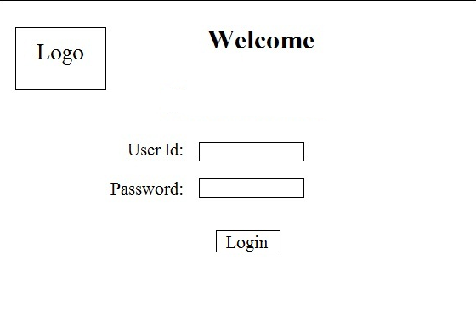

2. Registration Form

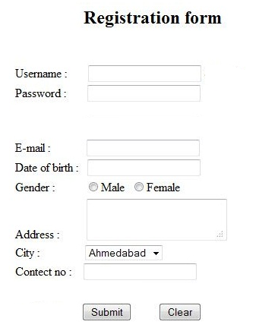

[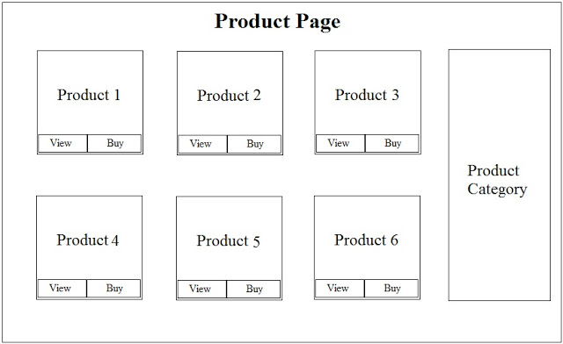](http://2.bp.blogspot.com/-ini1wn7dPYk/T3lyw7ki2uI/AAAAAAAAAIA/2WDPNzPSSRM/s1600/Product+page.jpg)

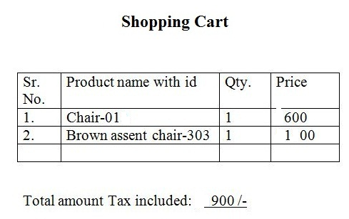

          4.2 Hardware Interface

The System must run over the internet, all the hardware shall require to connect internet will be hardware interface for the system. As for e.g. Modem, WAN – LAN, Ethernet Cross-Cable.

4.3 Software Interface

The system is on server so it requires the any scripting language like PHP, VBScript etc.The system require Data Base also for the store the any transaction of the system like MYSQL etc. system also require DNS(domain name space) for the naming on the internet. At the last user need web browser for interact with the system.

5. Performance Requirement

There is no performance requirement in this system because the server    request and response is depended on the end user internet connection.

6. Design Constrain

The system shall be built using a standard web page development tool that conforms to Microsoft’s GUI standards like HTML, XML etc.

7. AnotherNon-Functional requirement

7.1 Security

* The system uses SSL (secured socket layer) in all transactions that include any confidential customer information.
* The system must automatically log out all customers after a period of inactivity.
* The system should not leave any cookies on the customer’s computer containing the user’s password.
* The system’s back-end servers shall only be accessible to authenticated administrators.
* Sensitive data will be encrypted before being sent over insecure connections like the internet.

7.2 Reliability

The system provides storage of all databases on redundant computers with automatic switchover.

The reliability of the overall program depends on the reliability of the separate components. The main pillar of reliability of the system is the backup of the database which is continuously maintained and updated to reflect the most recent changes.

Thus, the overall stability of the system depends on the stability of container and its underlying operating system.

7.3 Availability

The system should be available at all times, meaning the user can access it using a web browser, only restricted by the down time of the server on which the system runs. In case of a of a hardware failure or database corruption, a replacement page will be shown. Also, in case of a hardware failure or database corruption, backups of the database should be retrieved from the server and saved by the administrator. Then the service will be restarted. It means 24 X 7 availability.

7.4 Maintainability

A commercial database is used for maintaining the database and the application server takes care of the site. In case of a failure, a re-initialization of the program will be done. Also, the software design is being done with modularity in mind so that maintainability can be done efficiently.

7.5 Portability

The application is HTML and scripting language based. So,the end-user part is fully portable and any system using any web browser should be able to use the features of the system, including any hardware platform that is available or will be available in the future.

An end-user is using this system on any OS; either it is Windows or Linux.

The system shall run on PC, Laptops, and PDA etc.

8. Operational Scenario

The customer wants to buy item. The system shows all product categories to customer. If customer select item then they listed in shopping cart for buying.

The payment will made with credit card or bank check. If customer wants to cancel the order before shipping then he or she can cancel it.

Customer can see the buying report on account detail.

[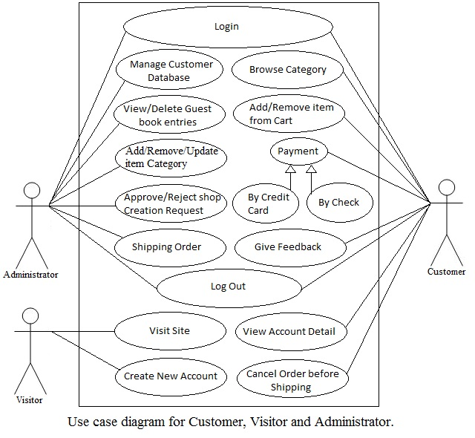](http://2.bp.blogspot.com/-X0Q7fkLSULM/T3nV0Nur2CI/AAAAAAAAAIo/XYDzSQSYwI4/s1600/custo%2Cvisitor%2Cadmin.jpg)